Step 1:

Open the project:

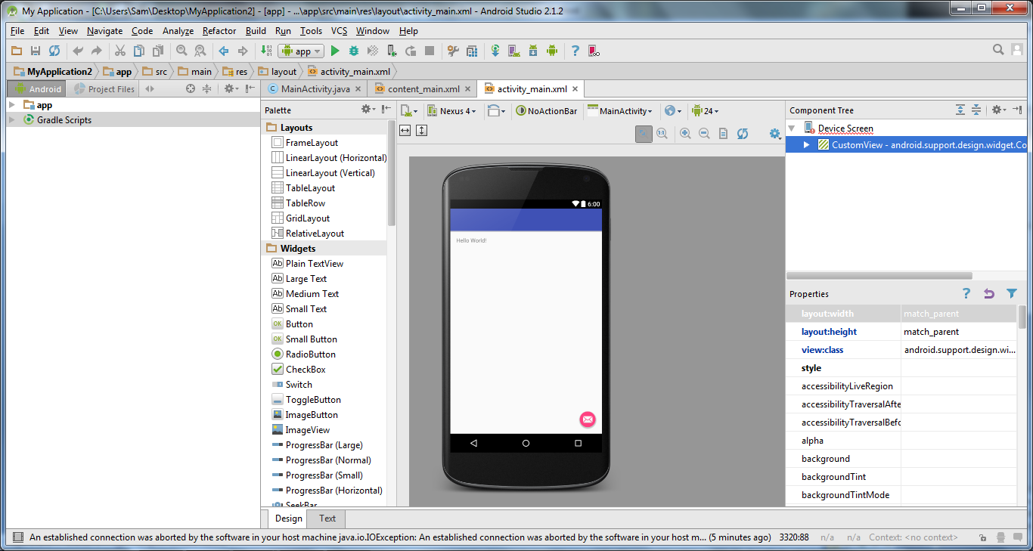

Step 2:

Browse Repositories for genymotion and Install Genymotion:

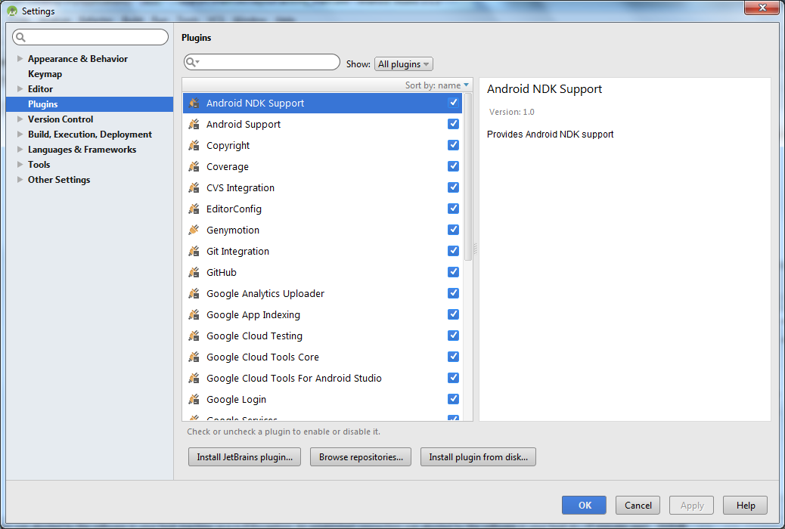

Genymotion icon appear

Step 3:

Genymotion icon appear on the task bar:

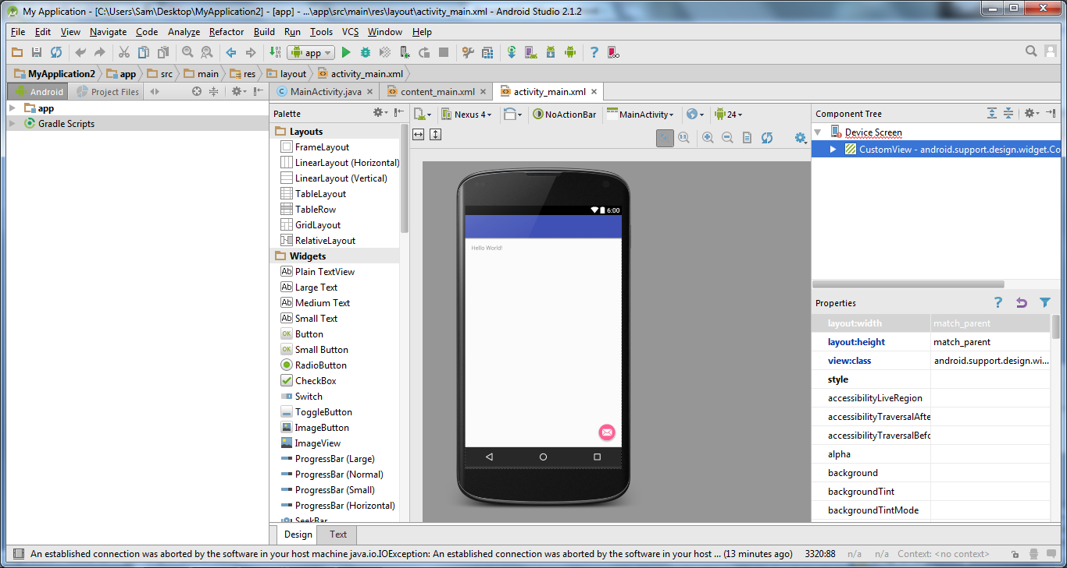

Step 4:

Click on the geny motion icon genymotion device manager appear:

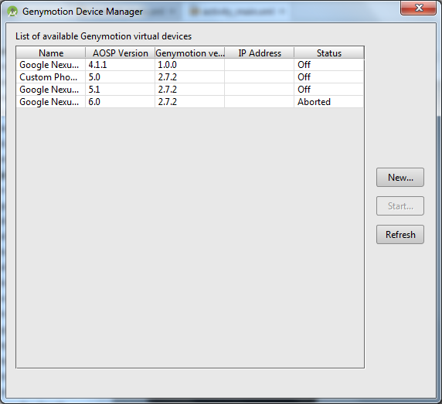

Step 5:

Select the created device and press Start:

